EEE | Practice problems (3-phase)

12.1 Given that , find V_{an} and V_{cn}, assuming a positive (abc) sequence.
Van’s angle – 120 = Vbn’s angle
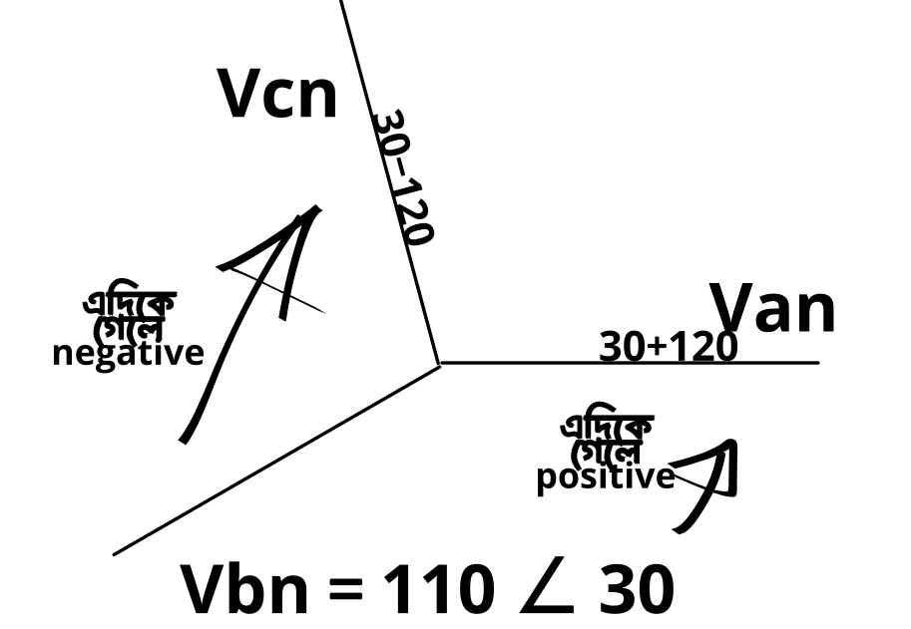

12.2 A Y-connected balanced three-phase generator with an impedance of 0.4 + j0.3 ohm per phase is connected to a Y-connected balanced load with an impedance of 24 + j19 ohm per phase. The line joining the generator and the load has an impedance of 0.6 + j0.7 ohm per phase. Assuming a positive sequence for the source voltages and that V_{an} = 120∠30 V, find: (a) the line voltages, (b) the line currents.
Line voltages = sqrt(3) x phase voltage + phase shift by ∠30
(a) for Vab (line vol) = sqrt(3) x 120 ∠(30+30) = 207.85∠60
অনুরূপভাবে, Vbc = 207.85∠(60-120)
Vca = 207.85∠(60-(2x120)) অথবা, 207.85∠(60+120)
^ (বই এ এভাবে করা আছে যদিও)
Line current = Phase current =
Likewise, ,

12.3 One line voltage of a balanced Y-connected source is V_{AB} = 240l∠20 V. If the source is connected to a dell-connected load of 20∠40 ohm, find the phase and line currents. Assume the abc sequence.
Phase current,
I_{ab} =

Line currents,
I_{a} = sqrt(3) x I_{ab} x ∠(-30) = sqrt(3) x 12 ∠(-60-30) = 20.78 ∠ -90 A
I_{b} = 20.78 ∠-210
I_{c} = 20.78 ∠ 30

12.4 A positive-sequence, balanced delta-connected source supplies a balanced delta-connected load. If the impedance per phase of the load is 18+ j12 ohm and I_{a} = 19.202∠35 A, find I_{AB} and V_{AB}.
I_{AB} = A (Line → Phase)
V_{AB} =

12.5 In a balanced Dell-Y circuit, V_{ab} = 240∠15 and Z_{Y} = (12 + j15) ohm. Calculate the line currents.
V_{an} =
I_{a} =
I_{b} = 7.21 ∠ (-66.34-120)
I_{c} = 7.21 ∠ (-66.34+120)

12.6 For the Y-Y circuit in Practice Prob. 12.2, calculate the complex power at the source and at the load.
At the source,
S_{s} = -3 V_{p}I_{p}* = sqrt(3) x V_{l} x I_{l} = sqrt(3) x 207.85∠60 x

